**Nintendo Switch[1]**

**Nintendo faces the following demands during the next three weeks: 2000, 1000 and 1500 Switch units, respectively. The production cost for each Switch unit for each week are as follows: week 1, $130; week 2, $140, and week 3, $150. There is a storage/holding cost of $20 per unit, assessed against each week’s ending inventory. Nintendo has 500 Switch units on hand at the beginning of week 1. Not all units produced during a week can be used to meet the current weeks’ demand. To model this, assume only half of the goods produced during any week can be used to meet the current week’s demand. Determine how to minimize the cost of meeting the demand for the next three weeks.**

**Discussion**

**The unique aspect of this problem lies in identifying the calculated or abstract parameters that are not explicitly mentioned in the input and drafting a balancing equation for them. Calculated parameters are those parameters that flow through the timeline of the problem, keeps updating itself by the balancing equation and impacts the objective and the decision variables. In this case, all the products made that are not used to meet the demand of week 1 are stored as inventory and is utilized to meet the demand of week 2, along with any new products produced in week 2. Note that there is also an initial inventory before starting production. It means that to satisfy the demands of week 1, utilize products produced in week 1 as well as the initial inventory (i.e. Inventory from week 0, $I_{O})$. The holding cost is the cost to store the products in inventory. This cost further adds to the total cost incurred.**

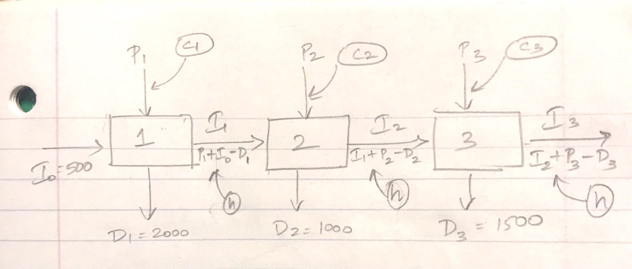

**Model**

Parameters:

$D_{i }$: *Demand for week $i$, $where i∈\left(1,2,3\right)$*

$C_{i}$: *Unit production cost for week $i$, $where i∈\left(1,2,3\right)$*

$H$: *Unit holding cost*

$α$: *Fraction of the goods produced during a week that can be used to meet the current week’s demand (here $α=50\%)$*

$I_{O}:$*Initial inventory*

Decisions:

$p_{i }$: *Units of products to be produced in week $i$, $where i∈\left(1, 2, 3\right)$*

Calculated Parameters:

$I_{i}:$*Inventory at the end of week $i$, $where i∈\left(1,2,3\right)$*

$I_{i}$ = $I_{i-1}$ + $p_{i}$- ${ D}_{i }$

Objective: *Minimize Cost*

+ *

Constraints:

$p_{i }≥0 \left(1\right)$ Units of products produced cannot be negative

2) Demand must be satisfied for each week

Notes:

1. The problem states that only half of the Switch units produced in a week can be used to meet the demand of that week. Therefore, constraint 2 ensures that units from inventory of the previous week and half of the units produced in the current week can meet the demand of the current week.
2. In theory, we can use $I_{i} ≥ 0$, which means that demand of each week is satisfied, i.e.

+ , sum of inventory flown in from previous week and current week’s production must satisfy the current week’s demand.

However, realistically, not all the products produced in a week can be used to satisfy the demand of that week, since production occurs throughout the course of the week, and at any moment, not all the units that are produced will be available. To account for this, the second equation considers only a fraction (half in this case) of the units produced in a week to be available to satisfy the demand of that week. See figure below for further illustration.

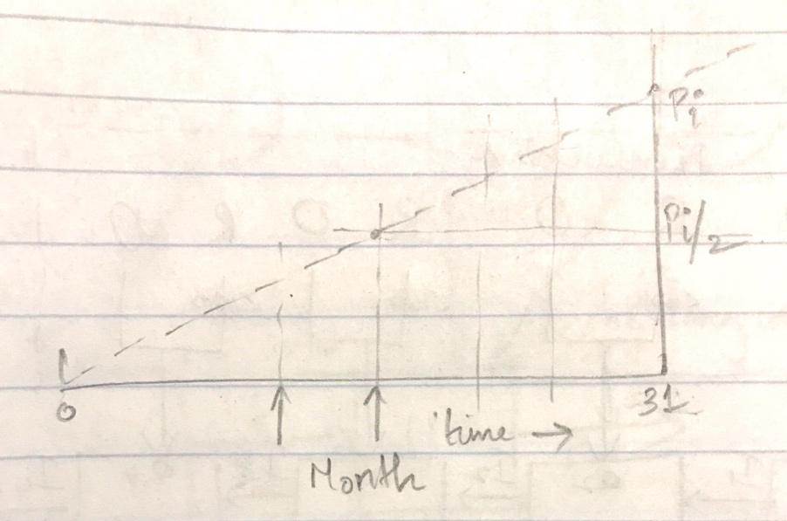

**Optimal Solution.** The following is the solution obtained from Excel Solver.



The optimal solution is to produce 3000 units in week 1, 1000 units in week 2 and no units in week 3. Note that it costs more to produce in Week 2 and Week 3, and there is also a smaller demand in Week 2. This means it would be cost effective to produce the most Switch units in Week 1, and allow it to carry over.

1. This exercise problem and related solutions were originally developed by Athira Praveen based on Practical Management Science 5th Edition. This vision is revised by Nowed Patwary.